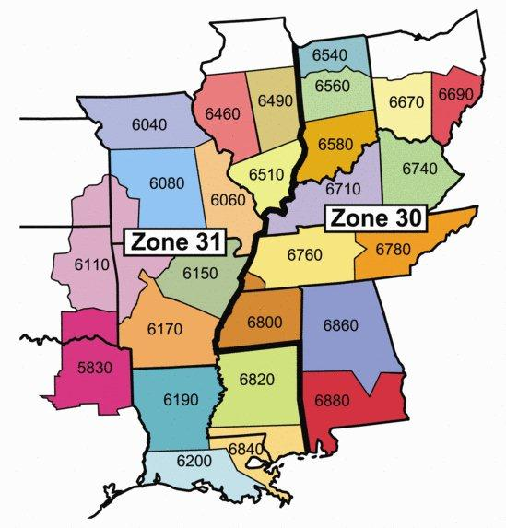

**ZONES 30/31 HEART OF AMERICA**

**ROTARY LEADERSHIP INSTITUTE**

**EXPENSE REIMBURSEMENT FORM**

|  |  |  |  |  |  |  |  |  |  |
| --- | --- | --- | --- | --- | --- | --- | --- | --- | --- |
| ***SECTION A*** | ***PAYEE INFORMATION*** | | | | | | | | |
| Submitted by: | | |  | | | | | RLI Position: |  |
| Street Address: | | |  | | | | | Your District #: |  |
| City, State, Zip: | | |  | | | | | Cell Phone #: |  |
| E-mail: | | |  | | | | | Date Submitted: |  |
| Event Location | | District: | | |  | City: |  | Event Date(s): |  |
| Payee Signature: | | | |  | | | | | |

|  |  |  |  |  |  |  |
| --- | --- | --- | --- | --- | --- | --- |
| ***SECTION B*** | ***TRAVEL EXPENSES*** | | | | ***AMOUNT*** | |
| Auto Mileage: | Miles       X $.565 (or current rate) = | | | |  | |
| Lodging:* |  | | | |  | |
| Meals:* |  | | | |  | |
| Other:* |  | | | |  | |
|  |  |  |  | | |  | |
| ***SECTION C*** | ***# OF PEOPLE:*** | | ***ON-SITE MEAL AND FACILITY EXPENSES*** | |  | |
|  |  | | | Meals (Faculty Dinner)* |  | |
|  |  | | | Meals and Breaks (RLI Event)* |  | |
|  |  | | | Other:* |  | |
|  | Facility Rental * | | | |  | |
|  | Office Supplies (Purchased locally)* | | | |  | |
|  | Printing (Purchased Locally)* | | | |  | |
|  | **Total** | | | |  | |

|  |  |  |  |  |  |  |  |  |  |  |  |  |  |  |  |
| --- | --- | --- | --- | --- | --- | --- | --- | --- | --- | --- | --- | --- | --- | --- | --- |
| ***SECTION D*** | ***EVENT/DISTRICT COORDINATORS EVENT SUMMARY*** | | | | | | | | | | | | | | |
| Event Attendance | | | Part I: |  | | Part II: | |  | Part III: |  | | | Faculty: | |  |
| Event Income: | | Prepaid Registration $: | | |  | | On-site Registration $: | | | |  | Total $: | |  | |

|  |  |  |  |  |  |  |
| --- | --- | --- | --- | --- | --- | --- |
| ***SECTION E*** | ***DISTRICT COORDINATORS SUMMARY AND EXPENSE APPROVAL*** | | | | | |
| Number of Expense Reimbursement Forms Attached: | | | |  | Total Expenses: |  |
| District Coord. Signature: | | |  | | Approval Date: |  |
| District Coord. E-mail: | |  | | | Cell Phone #: |  |

|  |  |  |  |  |  |  |
| --- | --- | --- | --- | --- | --- | --- |
| ***SECTION F*** | Treasurer |  | Check # |  | Date Check Sent |  |

*Receipts are required. See Reimbursement Form Completion Instructions in “Forms and Downloads” on Website.

Forward completed form(s) and receipts to District Coordinator for approval.

**District Coordinator** shall forward any checks received and all Expense Reimbursement Forms for a single event, **as one set**, by mail (or scan and e-mail) to: **Treasurer Frank Bradshaw, P O Box 54004, Lafayette, LA 70505.**

**District Coordinator** will also forward a copy of the expense report (no attachments) to the Regional Coordinator.

**Questions?** Contact Frank at [rotary6200@lusfiber.net](mailto:rotary6200@lusfiber.net) or [fbradshaw@lusfiber.net](mailto:fbradshaw@lusfiber.net) home: or phone 337-237-0628 (office) or 334-344-2020 (cell).